Synchronous and Asynchronous Communication

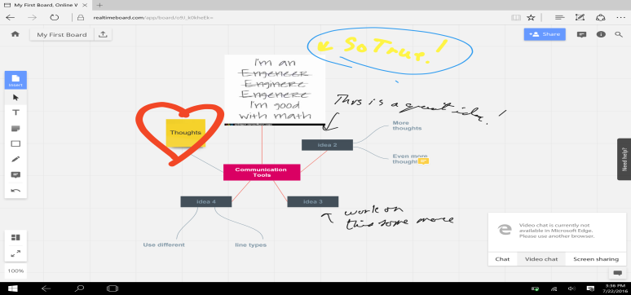
Synchronous – Realtime Board: https://realtimeboard.com/
Image of my exploration of Real Time Board Image of Real Time Board’s webpage

Asynchronous – wikispaces : https://www.wikispaces.com/content/classroom
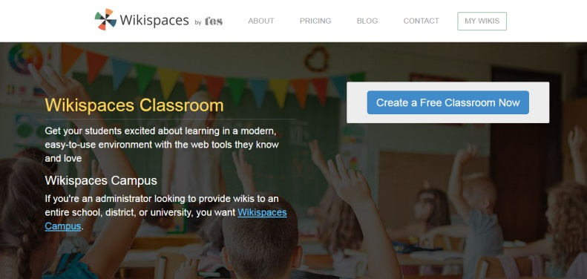
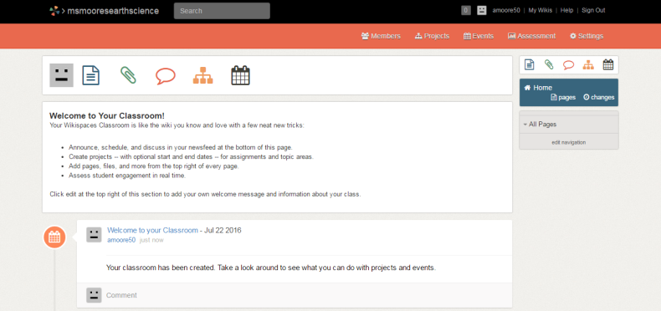
Image of wikispaces classroom webpage Image of my classroom’s future wiki page

  - The following table provides a side-by-side comparison of a synchronous and asynchronous communication tool along with several considered criteria.
Criteria | Synchronous – Realtime Board | Asynchronous – wikispaces
Summary / General function | Realtime Board is an online whiteboard designed for instant team collaboration despite distance between groups. | Wikispaces is a social writing platform specifically designed for multi-user collaboration on specific content.
Who benefits and why? | Anyone who needs to have a real time meeting for brainstorming, designing a project (product designers or homework assignment), project management, tutoring or distance education. This is great for people who don’t meet frequently due to distance constraints, but here they can still communicate instantly. | Anyone working in a collaborative group can benefit from this arrangement, such as classroom group work, or a corporate group project. More specifically, users who are normally quiet during group work could input their thoughts and ideas using this forum.
What types of interaction/higher order thinking/creativity does this tool promote? | The interaction is built into this tool as users promote ideas, collect feedback, and share with other users and their audience. This tool also increases organization and helps users manage the big picture as multiple frames can hold different parts of a project. Through the collaboration, students can test the other’s ideas in a non-threatening way through the comments or chat, increasing higher level thinking, and hopefully creativity. | This type of technology encourages interaction in designing the page and information gathering, knowledge sharing between groups and related pages using the linking ability, interaction using the commenting feature, and creativity in the organization and presentation of the material. Users, especially students, can investigate a topic and share their findings at their own pace, while also allowing others to give feedback through commenting.
Set up/ ease of use? | The sign-up process was easy with my work email and name. There is an opening introduction video and an option for a self-guided tutorial. | The sign-up process is relatively simple, requiring a unique username and web address.
Advantages | The basic account is free, and sharing it is easily done through email in the system. Little helpful hints pop up as you attempt different tasks. Multiple frames can be used to present the work as a presentation. There is a function where people can comment on specific parts of the board for discussion purposes. Also, the board can be privately emailed, or made public. Finally, there are chat, video chat, and screen sharing options for optimizing the synchronous communication. | For educators, the account is free. It is accessible anytime, and anywhere with an internet connection. Inspires interaction between members with the commenting ability, at their own pace. Ability to see complete page history allows for student monitoring or employee contribution. Users can embed content from around the web, including videos, images, polls, documents, and comment on sections of text or the entire page
Disadvantages | The website version isn’t super touch friendly for a tablet, as it tends to be overly sensitive to touch. This is unfortunate because I think this app would naturally lend itself to working on a tablet. Also, the video chat function is not available in Microsoft edge browser. | Lack of clear introductory instructions. The ability to make the website more visually appealing is lacking, resulting in a boring looking page.
Personal reflection | Unlike the wikispaces, the first page after signing up had a short and exciting introductory video that made me feel equipped to begin working on this site. The design is very user friendly, and the entire site is easy to use, especially with the template options. This is a technology I’d be happy to use and I will be sharing it with my coworkers and possibly integrating it into my curriculum. | Upon first creating the wiki account, I would have liked some guided navigation or start-up video to help guide me create my desired page. This made starting the first page rather daunting. Also, I would have liked some well done examples to be accessible, so I could get an idea of various formats, instead of having to search online for other’s wikis. But, for my intended use as a final class project of a knowledge repository, I think it will be easy to work with, and achieve the desired function.
7. Please also include how your group worked on the module in your reflection paper. Include your contribution to the group effort, any concerns or problems, any suggestions for improving group work. Also, use APA formatting in your paper.
Group Evaluation:
At the beginning of the module I used blackboard’s group email function to email my partner, John. I also posted an entry in the group blog as an experiment. By the end of the second, out of four possible days, I still had not heard back from my partner, so I explored the technology myself using two different computers. I perform this function frequently at work, so I know I was able to evaluate the technology adequately by myself. Still, I would have liked to work with a partner earlier in the assignment, because different people provide different perspectives and insights. I have no helpful suggestions for group work, as I see their validity, so sometimes the problem is simply a bad luck of the partner draw. Despite the lack of communication, I thoroughly enjoyed this project and the freedom to explore the technologies. It was an enlightening experience.
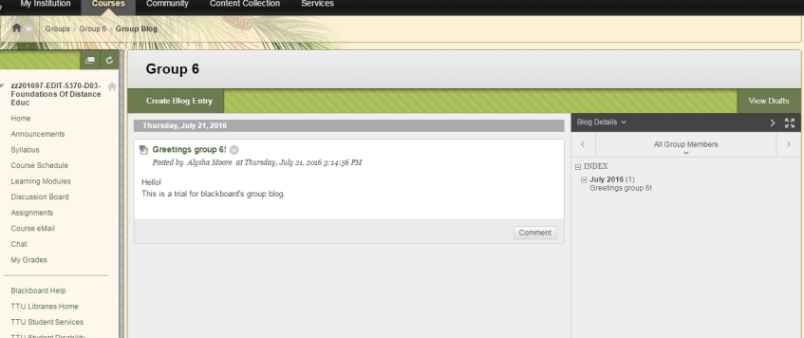
This image is of the group blog entry I created.

